1 实验内容

1. 税金的计算：文本框文字的监控

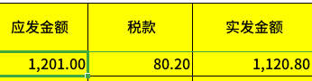

2 实验效果

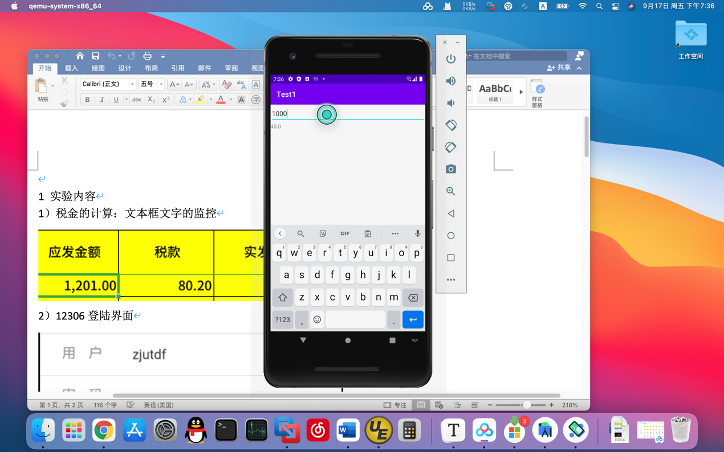

3 实现

fun calc(num1:Double):Double{  
 var tax:Double = 0.0  
 var _tax:Double = 0.0  
 if(num1 < 4000){  
 tax = (num1 - 800) * 0.2  
 }  
 else{  
 _tax = num1 * 0.8  
 if(_tax < 20000){  
 tax = _tax * 0.2  
 }  
 else if (20000 < _tax && _tax < 50000){  
 tax = _tax * 0.3 - 2000  
 }  
 else{  
 tax = _tax * 0.4 - 7000  
 }  
 }  
 return tax  
}  
  
class MainActivity : AppCompatActivity() {  
 override fun onCreate(savedInstanceState: Bundle?) {  
 super.onCreate(savedInstanceState)  
 setContentView(R.layout.*activity_main*)  
  
 val binding = ActivityMainBinding.inflate(*layoutInflater*)  
 setContentView(binding.*root*)  
  
 binding.txtMoney.addTextChangedListener(object : TextWatcher{  
 override fun beforeTextChanged(s: CharSequence?, start: Int, count: Int, after: Int) {  
 //*TODO("Not yet implemented")* }  
  
 override fun onTextChanged(s: CharSequence?, start: Int, before: Int, count: Int) {  
 //*TODO("Not yet implemented")* }  
  
 override fun afterTextChanged(s: Editable?) {  
 //*TODO("Not yet implemented")* var str = binding.txtMoney.*text*.toString()  
 // str -> num -> 计算 -> str  
 var num = str.*toDouble*()  
 var tax = *calc*(num)  
 str = tax.toString()  
 binding.tvTax.setText(str)  
 }  
  
 })  
 }  
}

<EditText  
 android:id="@+id/txtMoney"  
 android:layout_width="match_parent"  
 android:layout_height="wrap_content"  
 android:hint="请输入金额"  
 android:minHeight="48dp"  
 app:layout_constraintStart_toStartOf="parent"  
 app:layout_constraintTop_toTopOf="parent" />  
  
<TextView  
 android:id="@+id/tvTax"  
 android:layout_width="0dp"  
 android:layout_height="wrap_content"  
 android:text="0"  
 app:layout_constraintEnd_toEndOf="parent"  
 app:layout_constraintStart_toStartOf="parent"  
 app:layout_constraintTop_toBottomOf="@+id/txtMoney" />

1. 12306登陆界面

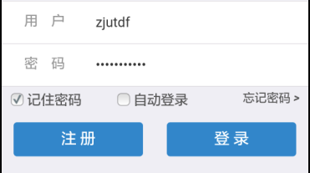

2 实验效果

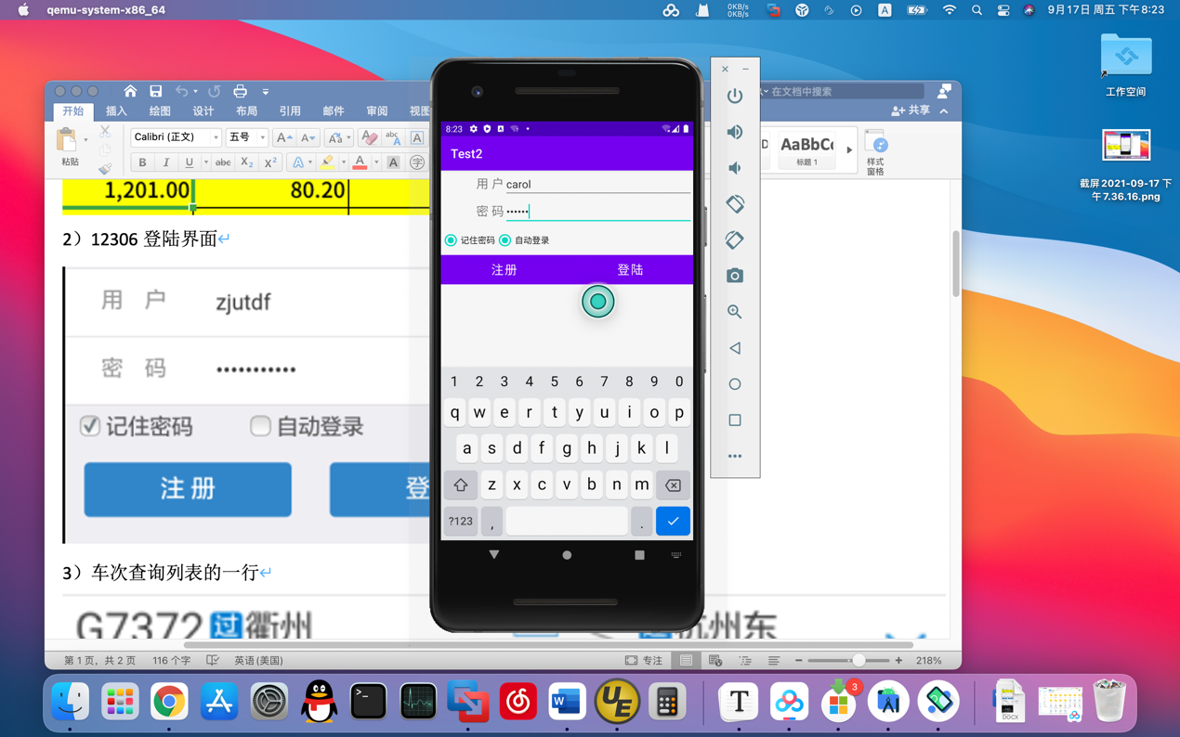

3 实现

<LinearLayout  
 android:layout_width="match_parent"  
 android:layout_height="wrap_content"  
 android:orientation="horizontal">  
  
 <TextView  
 android:id="@+id/textView"  
 android:layout_width="0dp"  
 android:layout_height="wrap_content"  
 android:layout_weight="1"  
 android:gravity="right"  
 android:text="用 户"  
 android:textSize="20sp"  
 />  
  
<EditText  
 android:id="@+id/edText1"  
 android:layout_width="0dp"  
 android:layout_height="wrap_content"  
 android:layout_weight="3"  
 android:hint="请输入用户名"  
 android:inputType="text"  
 />  
  
</LinearLayout>  
  
<LinearLayout  
 android:layout_width="match_parent"  
 android:layout_height="wrap_content"  
 android:orientation="horizontal">  
  
 <TextView  
 android:id="@+id/textView2"  
 android:layout_width="0dp"  
 android:layout_height="wrap_content"  
 android:layout_weight="1"  
 android:gravity="right"  
 android:text="密 码"  
 android:textSize="20sp"  
 />  
  
 <EditText  
 android:id="@+id/edText2"  
 android:layout_width="0dp"  
 android:layout_height="wrap_content"  
 android:layout_weight="3"  
 android:hint="请输入密码"  
 android:inputType="textPassword"  
 />  
  
</LinearLayout>  
  
<LinearLayout  
 android:layout_width="match_parent"  
 android:layout_height="wrap_content"  
 android:orientation="horizontal">  
 <RadioButton  
 android:layout_width="wrap_content"  
 android:layout_height="wrap_content"  
 android:gravity="center"  
 android:text="记住密码"  
 />  
 <RadioButton  
 android:layout_width="wrap_content"  
 android:layout_height="wrap_content"  
 android:gravity="center"  
 android:layout_gravity="right"  
 android:text="自动登录"  
 />  
</LinearLayout>  
  
<LinearLayout  
 android:layout_width="match_parent"  
 android:layout_height="wrap_content"  
 android:orientation="horizontal">  
 <Button  
 android:layout_width="wrap_content"  
 android:layout_height="wrap_content"  
 android:text="注册"  
 android:textSize="20sp"  
 android:layout_weight="3"  
 android:textColor="#ffffff"  
 android:background="#00ffff"  
 />  
 <Button  
 android:layout_width="wrap_content"  
 android:layout_height="wrap_content"  
 android:text="登陆"  
 android:textSize="20sp"  
 android:layout_weight="3"  
 android:textColor="#ffffff"  
 android:background="#00ffff"  
 android:layout_gravity="right"  
 />  
</LinearLayout>

1. 车次查询列表的一行



2 实验效果

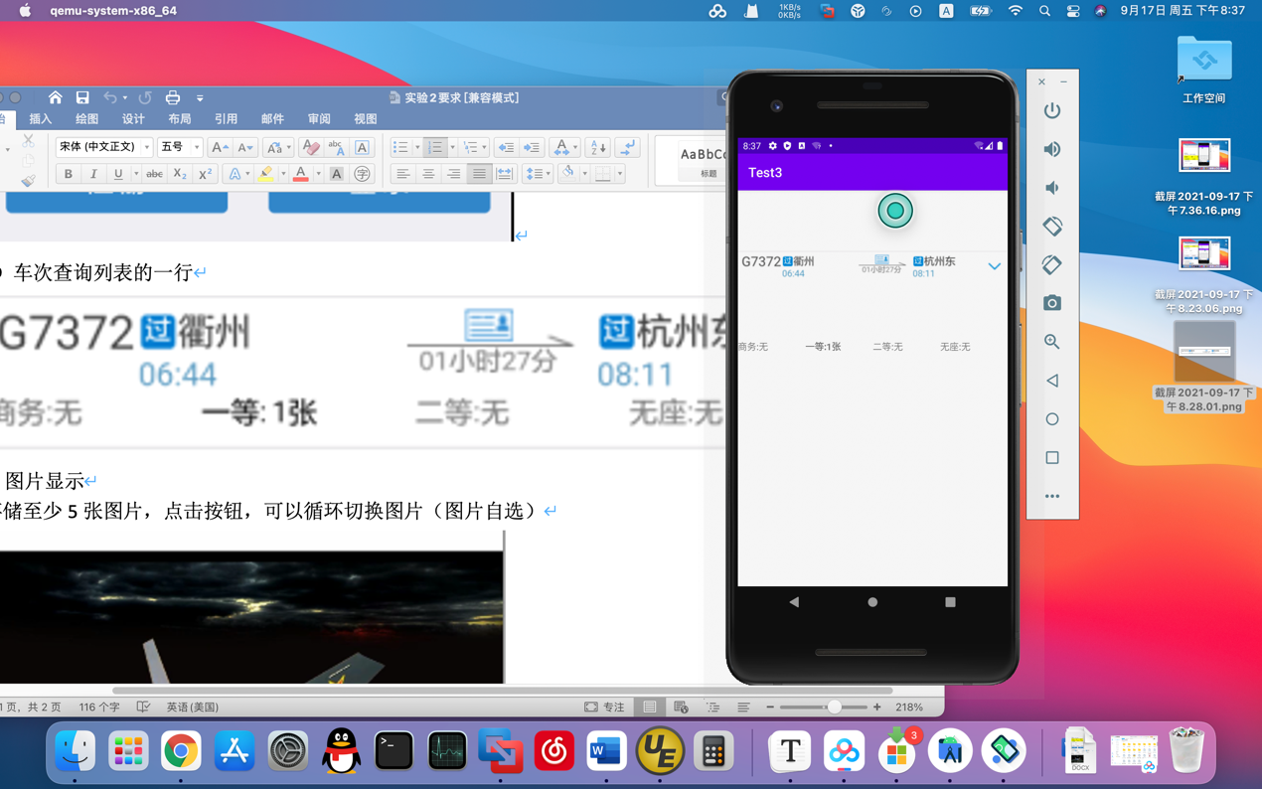

3 实现

<LinearLayout  
 android:layout_width="match_parent"  
 android:layout_height="wrap_content"  
 android:orientation="horizontal">  
 <ImageView  
 android:layout_width="match_parent"  
 android:layout_height="wrap_content"  
 android:src="@drawable/test1"/>  
  
</LinearLayout>  
  
<LinearLayout  
 android:layout_width="match_parent"  
 android:layout_height="wrap_content"  
 android:orientation="horizontal">  
 <TextView  
 android:layout_width="0dp"  
 android:layout_height="wrap_content"  
 android:layout_weight="1"  
 android:text="商务:无"  
 />  
 <TextView  
 android:layout_width="0dp"  
 android:layout_height="wrap_content"  
 android:layout_weight="1"  
 android:text="一等:1张"  
 android:textStyle="bold"  
 />  
 <TextView  
 android:layout_width="0dp"  
 android:layout_height="wrap_content"  
 android:layout_weight="1"  
 android:text="二等:无"  
 />  
 <TextView  
 android:layout_width="0dp"  
 android:layout_height="wrap_content"  
 android:layout_weight="1"  
 android:text="无座:无"  
 />  
  
</LinearLayout>

1. 图片显示

存储至少5张图片，点击按钮，可以循环切换图片（图片自选）



2 实验效果

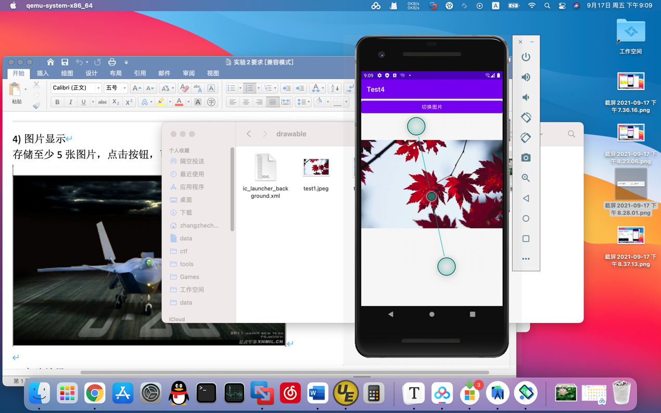

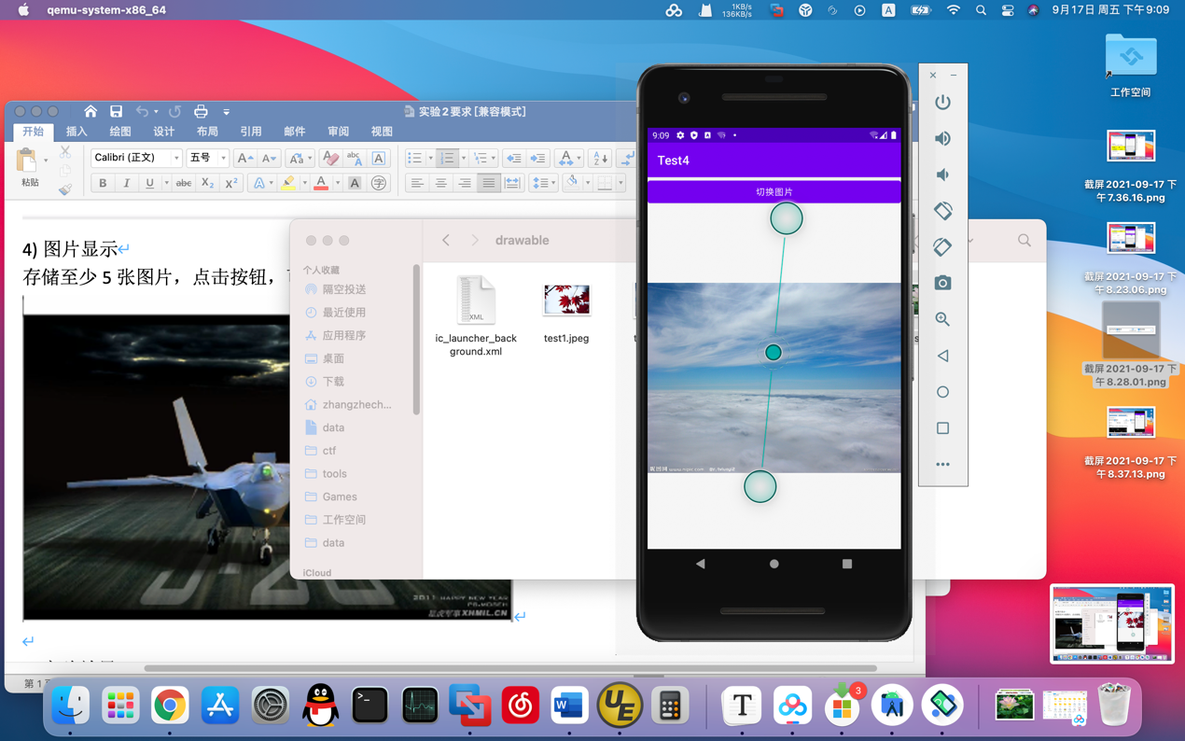

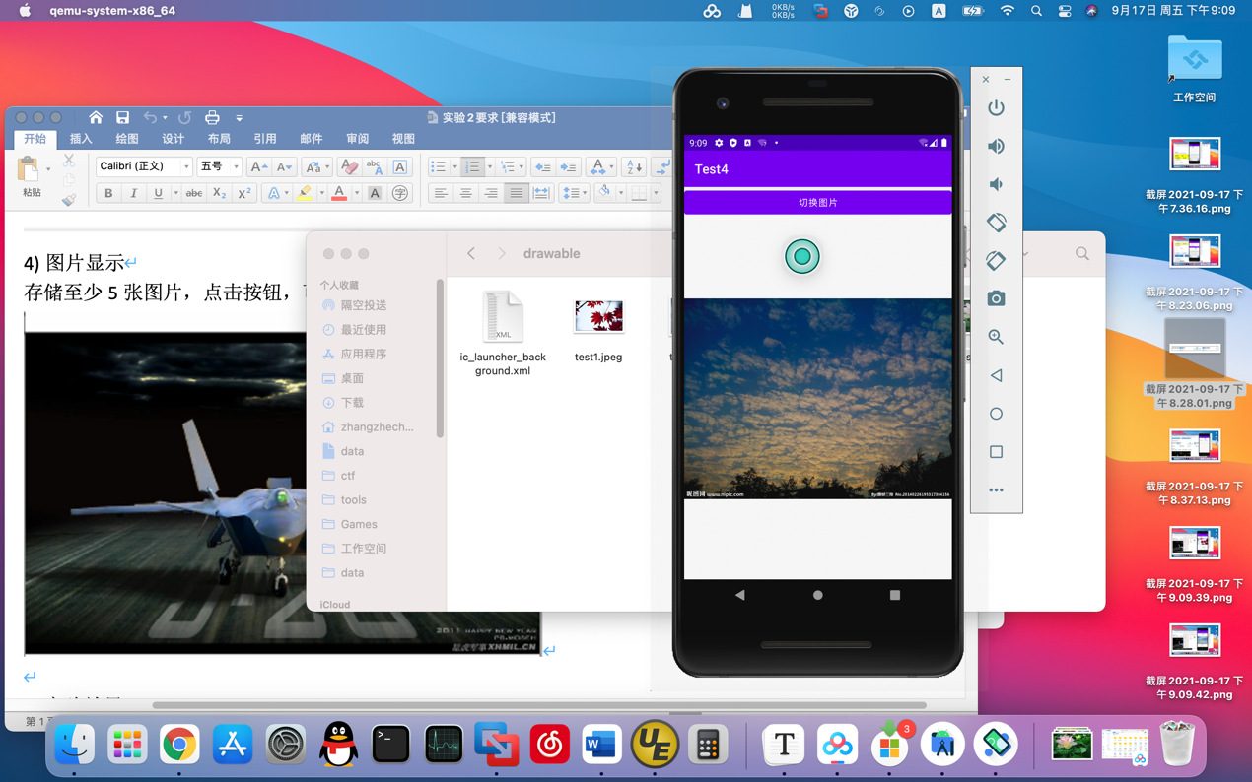

3 实现

<LinearLayout  
 android:layout_width="match_parent"  
 android:layout_height="wrap_content"  
 android:orientation="horizontal">  
 <Button  
 android:id="@+id/btn1"  
 android:layout_width="match_parent"  
 android:layout_height="wrap_content"  
 android:text="切换图片"  
 android:layout_gravity="top"  
 android:layout_weight="3"  
 />  
</LinearLayout>  
  
<LinearLayout  
 android:layout_width="match_parent"  
 android:layout_height="wrap_content"  
 android:orientation="horizontal">  
<ImageView  
 android:id="@+id/img1"  
 android:layout_width="match_parent"  
 android:layout_height="wrap_content"  
 android:src="@drawable/test1"/>  
</LinearLayout>

val binding = ActivityMainBinding.inflate(*layoutInflater*)  
setContentView(binding.*root*)  
var i = 2  
binding.btn1.setOnClickListener()**{** if(i == 1){  
 binding.img1.setImageResource(R.drawable.*test1*)  
 i++  
 }  
 else if (i == 2){  
 binding.img1.setImageResource(R.drawable.*test2*)  
 i++  
 }  
 else if (i == 3){  
 binding.img1.setImageResource(R.drawable.*test3*)  
 i++  
 }  
 else if (i == 4){  
 binding.img1.setImageResource(R.drawable.*test4*)  
 i++  
 }  
 else {  
 binding.img1.setImageResource(R.drawable.*test5*)  
 i = 1  
 }

1. 重点说明: 文本框如何监控
2. 和3）说明如何布局（可以手写，然后拍照）